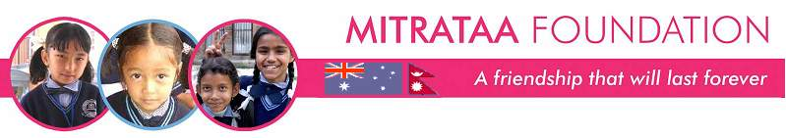
Volunteer Interest Form

About You:

Name: | Nationality: | Date of birth:
Languages spoken: | Email address: | Contact number:
Passions/interests/hobbies: (eg painting, dancing, writing stories etc):

Occupation and current job: | Professional experience: (please summarise here and attach your CV)
Education background:

Do you have any illnesses that require constant medication? If yes, please give details:

Have you spent any time in Nepal or a developing country before?

Do you have any experience with children? Please give details. This helps us work out which if our projects is best for you.

About your volunteer plans

When would you like to volunteer with Mitrataa? | For how long would you be able to commit to working with us? We generally require a minimum 2 week commitment. | How many of you are coming (ie are you travelling alone)?
Which of our projects are you interested in working with? Why? | As you can appreciate, we get a lot of requests for volunteer postings.. What do you think makes you stand out as someone we can’t say no to?
At Mitrataa, we love passionate, independent, creative people with big dreams. How does this fit with you?

Please write a short description about what you propose to do during your time as a volunteer with Mitrataa – eg what workshops, skills sharing, activities etc you believe you could share that would be beneficial to the Mitrataa family. We will work with you to come up with a program that meets our needs but we are interested in your ideas.

